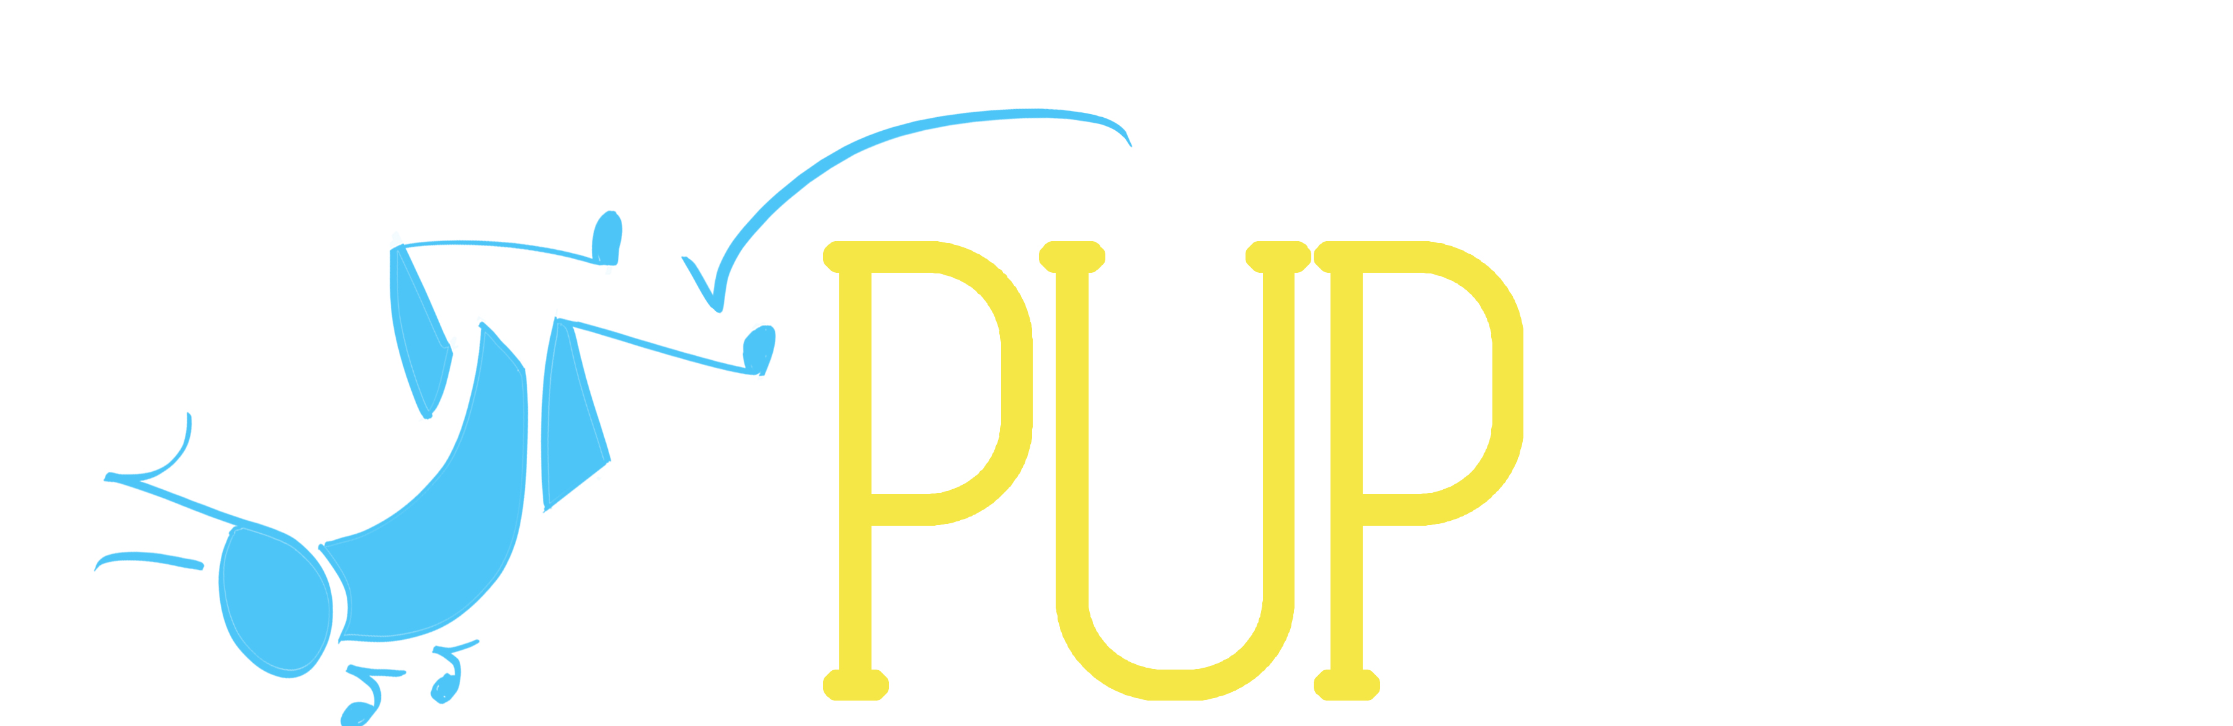

Princeton University Players
Workshop Proposal: 2014-2015 Season

Thank you for taking the time to fill out our original musical proposals form. We are so glad that you are interested in contributing to our season!

Each year, PUP produces 4-5 shows in venues all across campus. In addition to our mainstage season, we also produce workshops of original, student-written material! Original writers are still able to propose to our regular season, but we also want to provide a lower stress opportunity that is more focused on the process of creating musical theatre. This way we can encourage budding writers to create and showcase their work, at whatever step of the process they are in.

According to feedback from original writers in past years, one of the most helpful steps in developing a show is seeing how their material is interpreted in the hands of directors and actors. If you think you have a great concept for a musical, have already started working on an original piece, or have a musical fully written and ready for the work shopping, this is a great opportunity for you!

Please see the Proposals Calendar for important proposal process dates. Below is also list of the PUP Executive Board of 2014-2015. Because this is a relatively new facet of PUP, we anticipate (and hope!) that there are a lot of questions. Please direct them to Sarah Cuneo (ikasdin@princeton.edu).

Proposals Calendar:
March 9: Proposals Open House, Bloomberg 50, 12-2 pm
March 24: Proposals Form due (send to scuneo@princeton.edu)
March 25- April 20: Director Interviews
Late April: Directors Contacted
Early May: Official Season Announced
Mid May: Mandatory meeting for all directors of 2014-2015

PUP Executive Board 2013-2014:
President: Sarah Cuneo (scuneo@princeton.edu)
Vice President: Cameron Platt (cmplatt@princeton.edu)
Business Manager: Morgan Young (meyoung@princeton.edu)
Production Manager: Tyler Lawrence (tylerl@princeton.edu)
Technical Director: Daria Koren (koren@princeton.edu)
Publicity Chairs: Cat Andre (candre@princeton.edu)
Arianna Lanz (alanz@princeton.edu)
Development Director: Nathalie Ellis-Einhorn (nje@princeton.edu)

Expectations for Workshops

The workshop slot is intended to be flexible – the purpose of the workshop is to allow for student writers to develop new work on campus, so the goals of the process can vary from project to project and from playwright to playwright. Past PUP workshops have run the gambit in terms of final product: some have culminated in staged readings with binders, some have brought on directors to fully produce the show, and some have simply had the PUP board read through several drafts of the show in order to receive more feedback. Workshops of all shapes and sizes are welcome, so don’t be afraid to tailor your application to what you most want to get out of the experience!

Show Application

PART ONE:
The Show

- THE SHOW: Please submit everything you have written for your musical. This can include: book, lyrics, music, character outlines, timeline, etc. If you have the ability to record any of your songs, that will allow us to get a better sense of your show. While material will help us get a sense of your show, do not hesitate to propose if you’re still in the beginning stages and don’t have fully written songs or scenes.

- VISION: Though the original musical slot is intended for shows to be workshopped and is not involved, we would like to know your vision for the show – what you want to get out of the process, what you want the audience to get out of it, and why you think this is a show that should be written. Are there any scenes or songs you’re particularly excited about? What moments do you want to create on stage? On a more technical note, what kind of involvement would you like from the board? We would be happy to give our notes and advice part way through your process, or you can work independently.

- SCHEDULE: Give us an idea of when you want this show to be staged. It cannot conflict with any of our regular slots, but there are other times throughout the year that are great for this kind of work. Initial ideas include: Early Fall (first weekend of October), January (either during reading period or exams), Spring Break (performing the weekend after we get back from spring break, not during of course), or May (again either during reading period or exams). If you have any other ideas, please include those as well. Keep in mind that if you want a specific venue, you might need to be open to performances during the week. If you were given the time of year you wanted, what would be your timeline for finishing the show? As a reminder, it is not necessary for your musical to be finished when you propose it, but we would like to get a sense of what your goals and self-deadlines will be.

- VENUE: Because workshop productions are focused more on the material than the artistic production as a whole (i.e. minimal to no lights, props, costumes), and there is a great demand for performance spaces on campus, we ask that you be very flexible about where your work is performed. While we can’t guarantee a specific space, we do want to do our best to honor your preferences. Please list which venues you would like to work in, listing all the spaces you can think of. Be creative! Even if they’re not listed below, there are great spaces to perform workshop material on campus.

Venues: Matthews Acting Studio, Theatre Intime, Forbes Black Box, Frist Film and Performance Theatre, Wilson Black Box, Whitman Class of 1970 Theatre, Berlind Rehearsal Room, James Stewart Theater, Butler Amphitheatre, Rocky Common Room, Art Museuem.

PART TWO:
The Production Team

- OVERALL TEAM: Please provide as complete a list as possible of your production team for the show. We know that it is difficult to fill all these spots so far in advance, but try to at least fill up the main positions: stage director, music director, and stage manager. You are more than welcome to propose yourself as a director, though keep in mind that many writers find it helpful to see how others react to their work. If you are have trouble finding production team members, including director, contact ikasdin@ for a list of students that have worked on our previous shows.

Production Positions: Stage Director, Musical Director, Stage Manager, Production Manager, Assistant Stage Managers, Rehearsal Pianists.

- CREDENTIALS: Attach a resume of your theatrical experience. Please include previous performance and production work, as well as any theater classes taken. If possible, include a brief summary of the credentials of your stage director and music director. Also list your relevant contact information.

